Devised performance as a tool for public engagement in acute haematological cancers
Dr Alex Mermikides (Kingston University UK)
Background
Dramatic representations of cancer patients play an important role in engaging the public in their psychosocial experience and related biomedical science. However, mainstream formats such as Hollywood film, risk sentimentalising the subjective experience of the patient and ‘dumbing down’ the science. This research tests how an ‘alternative’ form of live performance engages audiences.
Methodology
A performance (entitled bloodlines) was created through ‘devising’, that is, through group collaboration rather than from an individually authored play-script. This creative methodology encouraged knowledge-exchange within the creative team (which included a survivor of adult ALL, his stem cell donor, medical experts and artists) and resulted in an unconventional dramatic form combining lectures and dance. Six public performances took place between July 2013 and April 2014 in UK and Antwerp. Audience responses were gathered through post-show questionnaires and interviews.
Results
Analysis of qualitative data indicates that the performance conveyed common subjective experiences of haematological cancer patients (for example, diagnosis and chemotherapy) in ways that cancer survivors felt were accurate, and that laypeople found engaging and thought-provoking (79% of respondents agreed). Likewise, key scientific and medical concepts (for example, healthy and pathological haematopoiesis, risk factors in transplant) were ‘conveyed in interesting and effective ways’ (93%). A key finding was that the ‘hybrid’ form of the performance (a result of the multi-disciplinary devising process) powerfully conveyed both the subjective experience and key elements of biomedical science – something that reflects the experience of patients who are confronted with unfamiliar scientific data.
Conclusion
‘Alternative’ dramatic forms, created in collaboration with medical experts and cancer survivors, can be considered a valid tool of redressing ‘sentimental’ and ‘dumbed down’ representations of the acute haematological cancer patient. In addition to increasing cancer literary among laypeople, benefits of such activities include providing cathartic experiences for cancer survivors, supporting bone marrow registry campaigns and increased empathy for cancer patients from caregivers.
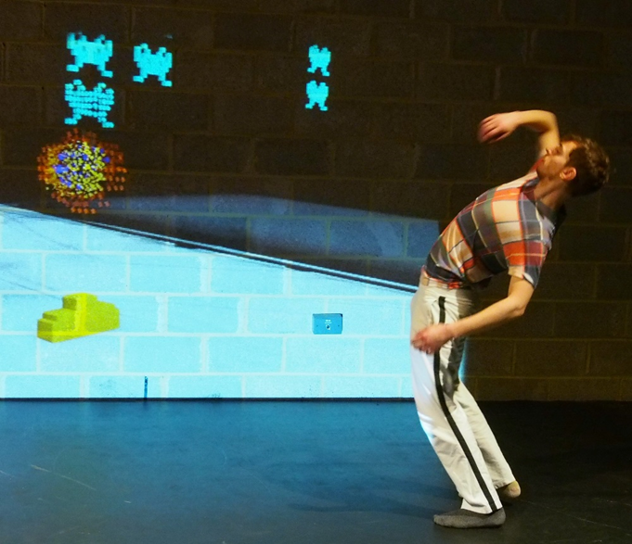
‘Chemotherapy’: dancer/choreographer Adam Kirkham in bloodlines. Photo by Richard Lane

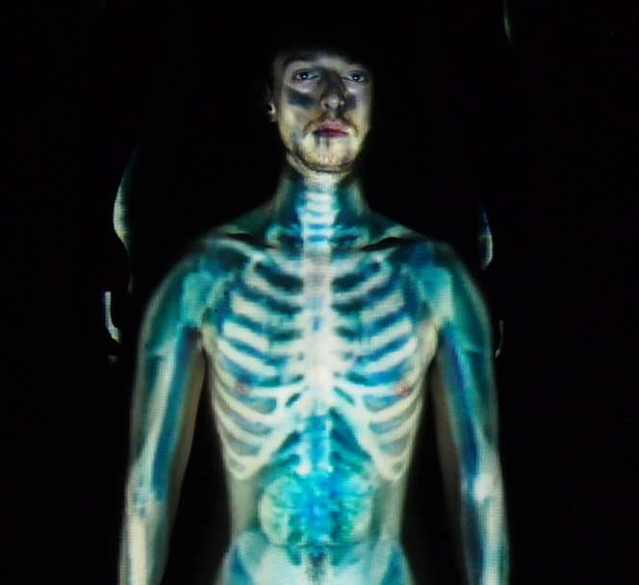
‘Total Body Irradiation’: dancer/choreographer Adam Kirkham in bloodlines. Photo by Richard Lane

